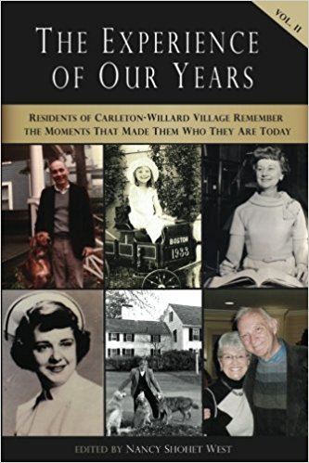
The Experience of Our Years, Volume II

Residents of Carleton-Willard Village Remember the Moments and Events That Made Them Who They Are Today

About the collection
Following up on Volume I, published in 2012, in 2017 journalist Nancy Shohet West returned to Carleton-Willard Village to ask a new set of participants, "What was the most formative event of your life? What experience, circumstance or situation do you credit for making you the person you are today?" This time thirty men and women, ranging in age from 79 to 103, responded, each in a different way. There were stories of chance encounters, professional opportunities, family strife, creative pursuits, and more. Topics range far and wide. For example:
- A high school dropout recognizes his mistake, returns to graduate from high school and goes on to earn a Ph.D. in education
- A newly ordained minister follows in the footsteps of her late mother to Labrador
- An ambitious young man changes the direction of his career during a military posting overseas
- A young mother realizes her child has a developmental disability and devotes her adulthood to advocating for other children like him
- A groundbreaking engineer looks back on the three mentors who paved his way to success
- A wife, initially stunned by her husband’s decision to move the family to a new state, discovers a new life for herself in middle age
- A college graduate refuses to listen to advice that would have directed her away from her ideal career
- A medical student who has long felt rejected by his own parents finds love and acceptance from the family of his future wife
But each story has one common element: they all resonate with the profound insight that comes from years of living, learning, and developing a unique understanding of the world.

About the editor
Nancy Shohet West is a freelance journalist in the Boston area. A frequent contributor to the Boston Globe, she has helped numerous individuals, families and communities create and self-publish their own memoirs. Find out more about her work at www.NancyShohetWest.com.
About Carleton-Willard Village
Carleton-Willard Village is a not-for-profit continuing care retirement community located in Bedford, Massachusetts. Established in 1982, it offers a complete range of services from apartments and cluster homes to supportive care, skilled nursing and rehabilitation services, and support for those with Alzheimer's disease and other dementias. Carleton-Willard Village was the first community in Massachusetts to become accredited in 1988, and is a teaching affiliate of the Boston University School of Medicine.
Published January 2018
Available from amazon.com
Paperback, 174 pages
ISBN: 978-1981406197
$15.00

